Brands Watch Display Counters for Britannia cruise ship
Brand: Britannia
Date: 2015
Catalog:Watch
Location: EU

Background
This is an order from a British contractor for the production of display cabinets for multiple international luxury brand stores on a newly opened European luxury cruise ship called britannia. The watch area includes brands such as Omega, TAG Heuer, Longines, Michael Kors, Fossil, Raymond well, Cityzen, ANNE KLEIN, etc., and the cosmetics area includes Dior, Lancome, etc. The cabinet styles were adjusted to fit the brand's design concept, and the craftsmanship involved standard wood baking paint, stainless steel decoration, tempered glass, and other mature and stable techniques. As a result, the drawings and production went very smoothly. The main challenge was the tight delivery schedule requested by the client, with a requirement to deliver within 2 weeks after the confirmation of the drawings. Although there were some unexpected incidents during the process, we managed to deliver on time in the end.
Production Details
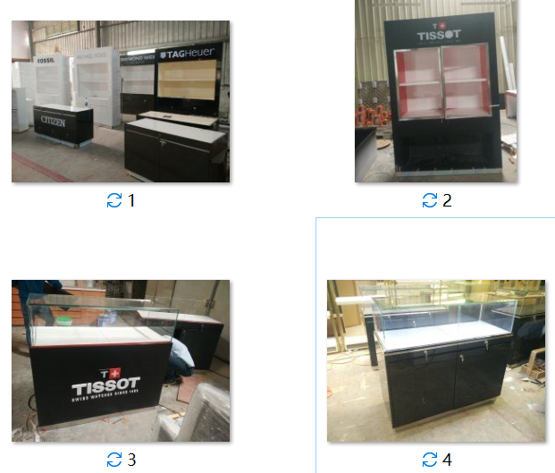
Opening Pictures

